
Hkkjrh; izkS|ksfxdh LkaLFkku iVuk
Indian Institute of Technology Patna
Dept. of Electrical Engineering
IIT Patna, Campus, Bihta, Patna, Bihar – 801103 Experiment- 3

POWER SUPPLY

OBJECTIVES: Design and analysis of full-wave rectifier and zener regulator.

MATERIALS REQUIRED

- Components :
Transformer : One: 230 V to 12–0–12 V (rms)
Diode : Two: Type 1N4007
: One: (Zener voltage VZ = 6.2 V)
Resistance : Three: 220 Ω, 560 Ω, 1 KΩ
Capacitor : One: 100 µF25V.

GENERAL GUIDELINES

1. Switch on the mains supply to the transformer only after you have made all other connections (in order to avoid electric shock).
2. Also, while making any changes in the circuit, switch off the mains supply to the transformer.

3. Connect the capacitor with correct polarity. The capacitor being of electrolytic type, it is polarized, and will be damaged if connected with incorrect polarity. Similarly, confirm the polarity of the diodes before connecting.

PART A: Unregulated Power Supply: Using center tapped Transformer and Full - Wave Rectifier (FWR)

i) Full-wave rectifier (FWR)

1. Set up the circuit as shown in Fig. 3.1 without the capacitor C. The transformer TX has rating of 230 V to 12-0-12 V, 1 A. Take RL = 1 kΩ. Connect transformer primary to the mains and switch on the mains. Display the secondary voltages VAG and VBG (VAG to Ch-1, VBG to Ch-2) on the DSO. Make sure that both the “Probe Grounds” are connected to the circuit ground. Sketch the waveforms overlapping, with the same time and Amplitude axes. They should be 180 degree out of phase.

- Display and sketch the full-wave rectified output Vo across RL . Measure the peak voltages in both half.

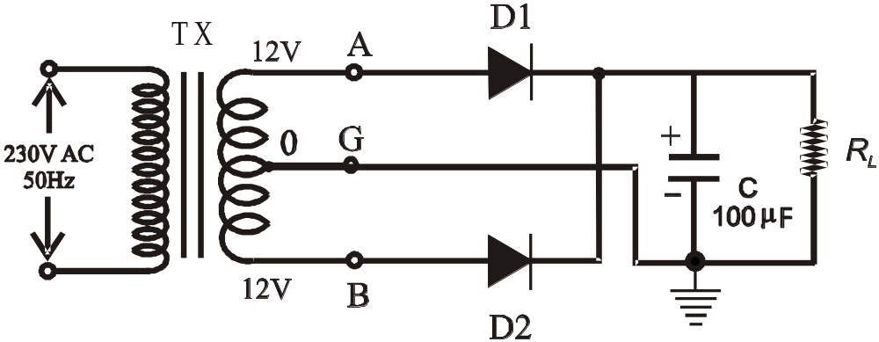

Fig: 3.1 :-Power Supply Using a center tapped Transformer and Full - Wave Rectifier

ii) Comparison with half-wave rectifier (HWR)
1. Remove diode D2. The circuit is now a HWR with C-filter.
2. Compare Vr values in FWR and HWR.
Q. 1 : What are the ripple frequencies in FWR and HWR?

PART B : Regulated Power Supply : FULL - WAVE RECTIFIER WITH ZENER REGULATOR

1. Connect a zener diode DZ with series resistance R = 560 Ω as shown in Fig. 3.2. The voltage across DZ will now be the desired (regulated) output voltage VoR which will supply current IL to the external load RL .

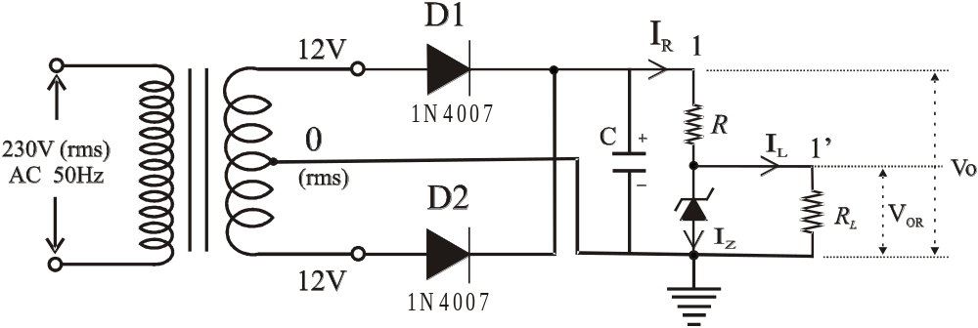2. With RL = ∞, using the oscilloscope measure Vo max , the maximum of Vo ( the unregulated DC along with ripple) & Vr (peak to peak ripple) at point -1 (unregulated output). Similarly obtain VoR max, the maximum of VoR (the regulated D C along with ripple) & VrR at point -1’ (regulated output). You will find VrR to be very small; hence you may have to increase the oscilloscope sensitivity suitably.

Fig. 3.2 Regulated Power Supply with zener diode.

3. Calculate : Vo av = Vo max – Vr / 2, and VoR av = VoR max – VrR / 2 ≈ VoR max . You will notice that the average regulated voltage VoR av ≈ VoR max (almost equal since VrR is very small).

4. Compute IR, IZ, and IL (all average values), and the power dissipations : PZ = VZ IZ, (VZ = VoR av), and PR = VR IR, (VR = voltage across R = Vo av – VoR av).

5. Repeat step 2 and 3 for RL = 1 kΩ and 220 Ω. Enter the measured and calculated values in a tabular form as shown below:

RL | Vo max  (DC Coupling) | Vr  (AC Coupling) | VoR max  (DC Coupling) | VrR  (AC Coupling) | Vo av | VoR av | IR | IL | IZ | PZ | PR | % Reg
∞
1KΩ
220Ω
560Ω

% Regulation is defined as:
% Reg = [{(VoR av) NO-LOAD – (VoR av)LOADED } / (VoR,av) NO-LOAD ] X 100

Q. 2 : Do you observe poor regulation for some IL? Why does it occur?

Q. 3 : What is the maximum load current the zener regulator (under test) can supply? Given that
IZ min = 5 mA and the maximum power dissipation in the zener is ½ W.

Q. 4 : How would you modify the circuit to provide an even higher IL ? What is this maximum value?

Q. 5 : What are the wattage ratings of the resistances you will use in the modified circuit for the maximum IL value obtained in Q.6? (Standard wattage ratings: ¼ W, ½ W, 1 W, 2 W, 5 W etc.)
Q. 6 : Have you used the correct wattage resistances for the circuit under test?

